**Use case 8**

**Domain: Electronics**

**Case- Use of AI for Bokeh effect in Portrait mode**

**Context:**

Smartphone cameras use artificial intelligence (AI) for portrait mode to create the popular "Bokeh" effect, which blurs the background while keeping the subject in sharp focus. Here's how it typically works:



**Data Collection**

* **Depth Sensing**:

Many smart phones are equipped with multiple cameras or sensors, which help in capturing depth information. Some common methods include using dual cameras (Stereo vision) or a combination of cameras and time-of-flight (ToF) sensors. These sensors capture the distance between the camera and various objects in the scene.

 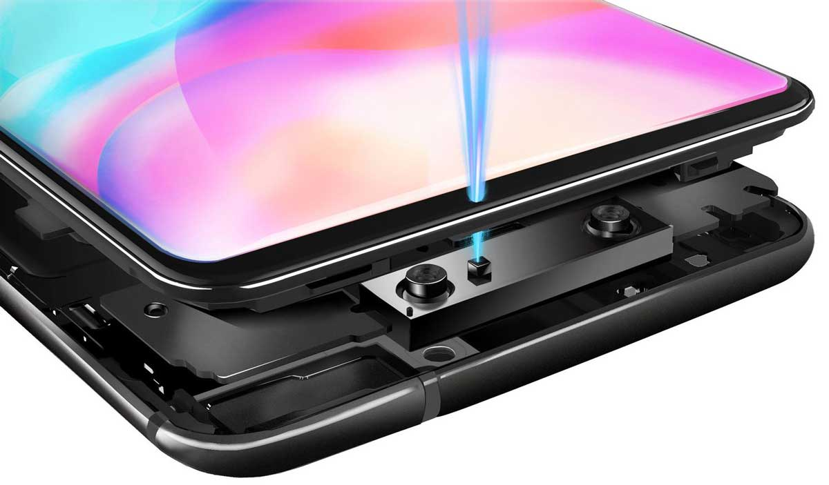

* **Subject Segmentation:**

The most common approach is to use a machine learning model. AI algorithms use the depth information and image analysis to identify the subject (usually a person) in the frame. This process is called subject segmentation. It involves distinguishing the subject from the background by identifying the pixels that belong to the subject.

* **Background Blur:**

Once the subject is identified, the AI algorithms create a depth map of the scene, highlighting the subject's depth while differentiating it from the background. The depth map is then used to apply a blur effect to the background.

* **Real-time Adjustments:**

In many Smartphone cameras, portrait mode is not a one-time capture but an ongoing process. As you compose the shot, the AI algorithms continually analyze and adjust the background blur effect in real-time, ensuring that the subject remains in focus while the background blurs, even if the subject or the camera moves.

* **Fine-tuning and Enhancements:**

Some Smartphone cameras also apply additional enhancements to the subject's appearance, such as skin smoothing or background lighting adjustments. These enhancements can be based on machine learning models that have been trained to recognize and improve portrait photos.

* **Post-processing:**

After capturing the photo, the Smartphone’s AI may continue to refine the portrait mode effect in post-processing. This can include further enhancing the subject's appearance, fine-tuning the background blur, and optimizing the overall image quality.

**Conclusion**

AI is implemented in smart phones to take beautiful pictures simulating the shallow depth of field you would get with a DSLR camera and a wide aperture lens.